BLOS HazCom – Appendix 5B

National Fire Protection Association Labeling System

Bigelow Laboratory uses NFPA labeling for all chemicals and solutions at our facilities.
The system relies on color (Blue=Health, Red=Fire, Yellow=Reactivity, White=other info) and Numbers (0 to 4, No Hazard to Great Hazard) to relay information quickly and easily.

A sample label is shown below, with detailed information for completion.

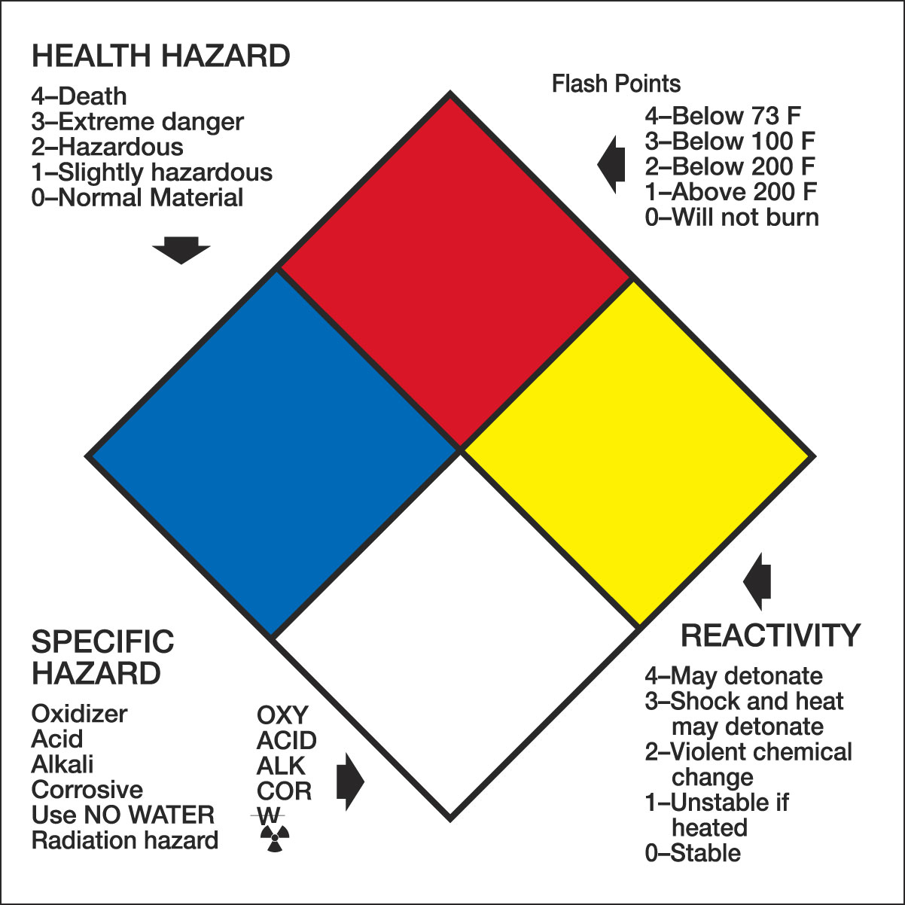

THERE SHALL BE NO UNLABELLED CONTAINERS OF CHEMICALS!

